# Expected functionalities

## Functional Modules

## Budget and Forecasting

Budget is a key functionality of any financial system. It should reflect the budget agreed with the donor (Global Fund, Government, Other donors) with the monthly phasing and the appropriate level of granularity. This level of granularity might be different from the posting accounts for actuals; however, it should be possible through a hierarchy to compare budget vs actuals. This variance analysis should be conducted regularly by the implementers to monitor the grant financials.

Depending on the level of control required, financial system should enable to set budget as ceiling amount for expenses (budgetary control). This control could be warning or blocking.

Initial budget could also be revised to reflect the changes of the grant lifecycle (delay in the expenditures, reallocation of budget between cost categories…). It should be possible to store initial and revised version of the budget to track the evolution and provide donors with accurate forecasts.

Generally, budget elaboration (prior to the budget agreement) is not managed in the ERP tool but in a dedicated budgeting tool or in Excel. Only the final result is stored in the Financial Management Tool.

As a summary, the key functionalities related to budget and forecasting are:

* **Capability to store agreed budget and revised budget in the financial system**
* **Budgetary control by Activities and Interventions**
* **Capability to report budget consumption, variance and accurate forecasts**

## General Ledger (GL)

General Ledger is the backbone of financial system since all the transactions posted in the sub-ledgers should impact GL. It should be monthly reconciled and closed to ensure that transactions are recorded in the current month. Closure should prevent the posting of entries in the closed period. Specific Journal could be used for adjustments.

As reliable source of truth, GL should be the source of many reports for audit or donors purposes (trial balance based report). To meet donors’ requirements, GL chart of accounts (CoA) could be mapped with donors costing dimension (cost inputs for the Global Fund). It should be possible to maintain several mapping tables in parallel to be able to report to several donors with one unique system.

GL should also allow to manage several currencies. Each time a transaction is recorded, user should select the transaction currency (Transactions could be in different currencies – multi-currency functionality). Based on periodic FX rate, transaction amount should be automatically converted in reporting currency (Several reporting currencies could be enabled). FX gain and loss, monthly re-evaluation of balance sheet items should be recorded automatically by the system.

Global Fund grants are supposed to be exempt from paying taxes such as VAT. Whenever the expense being entered includes VAT, we should be able to indicate as such in the financial system, which should then automatically calculate the VAT amount and record it in the VAT receivable account. This account will then be cleared once a refund has been received from the government. When no refund is received for some of the amounts, these will then be posted as unrecoverable taxes, on the P&L.

Financial system should be also able to automatically calculate withholding tax, where applicable, and post it in the withholding tax payable account. Where an invoice includes VAT, the systems should be able to exclude the VAT before computing the amount to be deducted as withholding tax. The withholding tax payable account will be cleared once the cash has been paid (if applicable).

As a summary, the key functionalities related to GL are:

* **Automatic reconciliation of GL with sub-ledgers**
* **Accounting journal adjustments for current and previous periods**
* **Month-end closure capability**
* **Automatic re-evaluation of open balances (monthly or quarterly)**
* **Reporting capability (trial balance, customized report for donors based on mapping table…)**
* **FX management**
* **Tax Management**

## Accounts receivable (AR) and payables (AP)

Sub-ledger accounting (AR and AP) is a way to record transactions with third parties (Funding entities “customer” / supplier) and to manage payments related to those transactions. As explained above, sub-ledger accounting should be reflected in GL at least on a daily basis (ideally in real-time).

AP and AR modules are also the trigger for cash flows (cash receipt or disbursement). They should be able to provide with reporting of receivables / payables by due date (aging balance). In the procure-to-pay process (P2P), AP enables to record liability (with a link to the purchase order if any) based on supplier invoices.

AP is also the module where Supplier Master Data is generally managed. Master Data Management is a key principles of ERP system since master data are shared across the module which makes data quality critical for business transactions.

As a summary, the key functionalities related to AR and AP are:

* **Automatic reconciliation of AP and AR transactions with GL**
* **Integration with Cash Management**
* **Automatic re-evaluation of open balances (monthly or quarterly)**
* **Reporting capability (Aging balance, Open invoices / receivables…)**
* **Supplier Master Data Management (shared with Procurement module)**

## Procurement

Procurement is the first step of the procure-to-pay (P2P) process and is critical since it leads to sign a legal agreement with a supplier (contract or purchase order). As soon as this agreement is signed by both parties, implementers should recognize an (off balance sheet) commitment and budget should also be impacted when agreement (purchase order – PO) is approved in the system.

Upstream tendering process could be managed in the system but it is not mandatory as there is no financial impact. However, tendering process has to be duly documented since it is a frequent source of conflict of interest.

Procurement module has to embed approval hierarchy to guarantee that submitted PO are duly approved (according to signature authority) before being sent to the supplier. Once goods / service are delivered, user should be able to record the receipt in the system by matching with the PO. Receipt usually triggers the P&L impact in accounting and if needed impacts asset / inventory as well.

Once invoice is received, it is matched with PO / receipt and ensure that invoice amount cannot exceed receipt. Invoice is the basis for future payment as a consequence, the quality of supplier master data is key (especially bank details) to make sure that payment process will flow smoothly.

Depending on the functional scope, additional modules related to Supply Chain processes may also be relevant (Warehouse management, Transport Management…). Integration of those modules with procurement, inventory and finance modules is generally native for major ERP systems.

As a summary, the key functionalities related to procurement are:

* **Commitment accounting to impact budget and reporting**
* **Capability to manage approval hierarchy for PO**
* **Automatic control between PO, receipt and invoice**
* **Quality of Supplier master data (Data cleansing prior to the system implementation)**

## Asset and Inventory Management

Capability to track goods and monitor level of stocks is a must have for implementers. It is relevant to manage those requirements through the financial system as it is closely integrated with the procurement process (and especially the receipt of the PO). As soon as goods are delivered, system should be able to assign them basic information such as a location, quantity, dates, and technical characteristics. Assets could be recorded as expenses in the system but tracked as physical good (including asset transfer and disposal.

Based on this information, automated reports could be generated periodically to provide asset register, level of stock …

As a summary, the key functionalities related to asset and inventory management are:

* **Integration with procurement module to automate asset / inventory entry**
* **Capability to record asset / goods movement**
* **Standard reporting to track assets and monitor stocks**

## Cash Management

Cash management usually covers the management of the cash flows (cash-in and cash-out) and the relation with the banks through payment file and bank statement integration. Capability to send from the financial system electronic payment file to banks guarantees security standards in the cash flows. Financial Management System should also enable an automated integration of bank statement though a secured channel. This automation eases the bank reconciliation and ensures that balances of the bank accounts reflect the cash position at the bank.

Consequently, reporting on cash is more accurate, timely and reliable. Based on AR and AP due dates (in sub-ledgers), financial system could also provide cash forecast position (shot-term).

As a summary, the key functionalities related to cash management are:

* **Automated integration of bank statement & generation of payment file**
* **Automatic bank reconciliation**
* **Capability to report cash balance and cash forecast**

## Human Resources (HR)

Human resources module is not critical to ensure a proper financial management as long as payroll costs are posted in GL on a monthly basis. Payroll could be generated from HR module assuming the module maintain an exhaustive & up-to-date employee database as well as a mapping of payroll elements with GL accounts. In this case, HR module is managed like a sub-ledger that sends entries to GL on a monthly basis.

## Reporting

System should be able to manage regular country reporting (Financial Statements…) and Global Fund (and other donors) specific reports. The table below lists some usual reports that should be covered by Financial System. The list has to be updated with country specific reports.

| **Report** | **Description** |
| --- | --- |
| Pre-posting report | For every transaction, once it has been entered, but before it is posted, we should be able to generate a report that shows what GL codes are going to be debited and credited, as well as what other dimensions have been entered and exactly what information is going to be recorded about this transaction, e.g. what GF cost input, cost grouping, intervention, module etc. will the transaction be recorded as. This report can then be reviewed by the Finance Manager before the transaction is posted. |
| Expenditure reports | We would like to be able to run reports that can show us expenditure by different dimensions including:   * Expenditure by activity * Expenditure by intervention * Expenditure by module * Expenditure by cost grouping * Expenditure by implementers (PR/SR etc.) * Expenditure by SR * Expenditure by location (HQ, National, Regional, District, Community) * Reprogrammed expenditure |
| Budget variance analysis reports | The budget for each grant must be entered into the system at the beginning of the grant. The budget should be entered for each quarter.  We should then be able to generate a variance analysis report as and when required. The report should show current period and cumulative period variances.  There should also be an option to run the report with a current period of:   * Monthly (Finance Team and Program Managers) * 3 months (as required for management meetings) * 6 months (as required for the PUDR report submitted to the GF semi-annually) * 12 months (as required for the Annual Financial Report submitted to the GF annually).   The cumulative period variance should have the entire grant budget vs. the expenditure incurred to the cut-off date of the report or current date.  We would like to be able to run the variance analysis report in different formats including:   * Expenditure by activity vs budget by activity * Expenditure by cost grouping vs budget by cost grouping * Expenditure by intervention vs budget by intervention * Expenditure by module vs budget by module * Expenditure by implementer vs budget by implementer     We will therefore need to input the budget in as much detail. |
| Other reports | VAT receivable  WHT payable  Open advances (unaccounted)  Annual financial statements (based on IFRS or local norms) |
| Project Report | Standard grant financial report by donor with the following aggregated information:  Project Number, Donor, Disease, Implementation Period, Total Approved Budget, Grant Agreement Amount, Total Disbursement Received, Total Actuals (Paid & Unpaid separated), Open Commitments (Invoices & Not Invoices separated); Disbursement rate (total disbursement/Total grant agreement amount), Expenditure rate (total actuals/Total Approved Budget), Payment rate (total payments/total disbursements), Cash Balance (BRS), Bank statement balance (end of period bank balance) and Fund balances (Budget-total actuals-open commitments). |
| Global Fund Specific Standard reports | TGF specific report on Quarter Financial Update (Attached)  TGF specific report on Progress Update Cash Reconciliation  TGF specific report on Annual Financial Report – AFR (Attached)  Standard activity report by project with budget, commitment (2 levels); actual (paid & unpaid)  Standard periodic payment forecast for up to 3 years  Standard Trial Balance by project, donor, and consolidated  Trial Balance by Costing Dimension  Consolidated standard Income Statement  Consolidated standard Statement of Financial Position (Balance Sheet)  Consolidated standard Statement of Cash Flow  Project standard Income Statement – with a separate column for PR, Implementing Entities & SRs  Project standard Statement of Financial Position (Balance Sheet) – with a separate column for PR, Implementing Entities & SRs  Project standard statement of Cash Flow – with a separate column for PR, Implementing Entities & SRs |

*Templates for budget will be found as appendix*

## Data Modeling

Reporting capabilities are very dependent on the data model implemented in the system. Most of the systems offer a standard data model that may be customized with additional dimensions / user-defined table. Please find below an example of data model (including mapping tables) for accounting entries in GL.

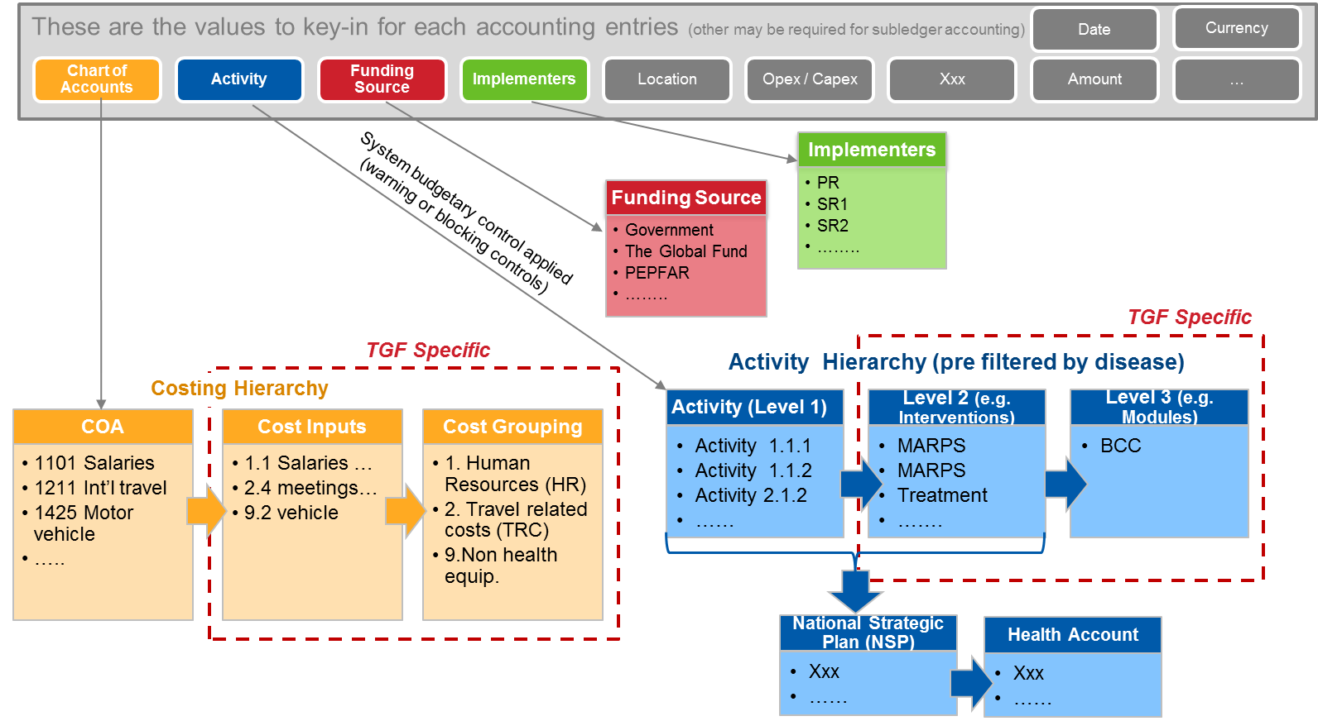

**Charts of accounts**

| **Dimension** | **Comments** |
| --- | --- |
| Chart of Accounts (CoA) | This is a mandatory field to record accounting entries. CoA has to be mapped with Global Fund’s cost inputs to be able to provide reporting by cost inputs to The Global Fund. |
| Funding Source | This is a mandatory field to differentiate donors and/or own resources. |
| Grant | This is a mandatory field to track different grants in the system. This dimension should not be limited to GF |
| Activity | Each grant has specific activities that fall under it. Attachment shows that each activity is also mapped to a particular intervention and a module.  This mapping should be included within the financial system such that when an activity is selected, the expenditure will also be automatically recorded under the relevant intervention and module. This will enable to generate reports showing expenditure by activity, expenditure by intervention and expenditure by module.  This Dimension should be visible in the payment screen to facilitate cash basis reporting.  For country needs, Activity can be mapped also to National Strategic Plan and Health Accounts.  This is a mandatory field. |
| Implementer | Implementation will either be done by Principal Recipient (PR) or by sub-recipients (SRs). Therefore the implementer will either be PR or SR.  If SR is selected as the implementer, then a unique code to identify the SR must also be entered. Such that report can be run to show expenditure by implementer, and another to show expenditure by SR.  Current SRs include SR1, SR2, SR3, SR4, SR4, SR5, Etc …... These acronyms can be used as their unique identifiers.   1. **Name of Organizations**    1. **Principal Recipient**       1. Implementing Entities          1. Name of Regional Hospital XXXX          2. Name of Regional Hospital XXXY          3. Name of District          4. Name of Facilities          5. Name of CBO          6. ……..       2. Procurement Agents          1. PPM – PFSCM          2. PPM – IDA          3. Agent 1          4. Agent 2          5. …….    2. **Sub-Recipients**       1. SR1       2. SR2       3. ……   This is a mandatory field. |
| Geography/Location | This will either be Headquarters, National, Regional or District, as that is generally where activities are implemented.  Being able to analyze the cost inputs by these three locations will be very useful for budgeting. Therefore, when entering an expenditure, an option to record the location should also be available. This should not be a mandatory input because it will not be relevant for all expenditures e.g. program management costs.  If a report is generated to show expenditure by location, then all expenditures where no location was selected should be categorized as “Location not indicated”. |
| Transaction type | This should be a mandatory input before an expenditure is posted. It will help to correctly post accruals, fixed assets, inventory and any other transaction types. |
| Reprogrammed Expenditure | Where they are savings, donor can be requested to approve expenditure on activities that may be over and above the budget or were not budgeted for, but are considered to be necessary. This is referred to as reprogramming. Wherever such expenditures are incurred, it is necessary to flag it as such, so that at any point in time, a report can show how much has been spent from reallocation or reprogramming requests. This is not a mandatory field as it does not apply to all transactions. |
| Staff code | For contingencies, system should enable to record the staff codes, such that you can track which member of staff has an outstanding advance. On a monthly basis, you should be able to generate a report to show unaccounted for advances by staff. This is not a mandatory field. |